**Tianshuo Zhang**

Adelaide SA 5000

0416 778 515

tianshuozhang325@gmail.com

<https://github.com/TianshuoZ>

**CAREER STATEMENT**

Desirous of an Software Engineer role in a challenging workplace that welcomes innovative ideas and offers growth opportunities and positive environment for accomplishing projects. A variety of computer language development experiences (C++, C, Python, Java, JavaScript, PHP, NetLogo). Have a variety of professional software tools experience (IntelliJ IDEA, Git, Visual Studio 2017). Participated in the employee login system during the internship(PHP). Participated and completed The rescue robot project, The park public facility reservation app, and The software project unusual event detection system during the Master degree. Powerful algorithm construction and implementation strength. Rigorous logic analysis strength. Hold M.Tech in Software Engineering from The University of Adelaide(GPA: 5.0).

**SKILLS & CERTIFICATES/CLEARANCES**

**Technical Skills:**

* Computer language: Java, C++, C, Python, PHP, SPI language, NetLogo, HTML, SQL
* Database - MySQL, Oracle, SQL Server
* Operating System - Windows, Linux, Linux(Raspbian)

**Soft Skills:**

* Problem-solving
* Critical thinking
* Teamwork skills
* Logical analysis

**EDUCATION**

Jul 2017 - **Master of Software Engineer**

Jun 2019 University of Adelaide, South Australia

Sept 2011- **Bachelor of Software Engineer**

Jul 2015 Soochow University, China

**EMPLOYMENT**

May 2015 -  **Zhenjiang Municipal Government, Employee login system**

June 2015Zhenjiang, China

* Edit the front-end pages using the PHP programming language
* Design the front-end tables using the PHP programming language
* Build a programming environment with WampSever as a server
* Manage MYSQL database with PhpMyAdmin tool

**PROJECTS**

Nov 2018-  **Project: Construction of NetLogo models such as farms, flocks, and traffic jams**

Jul 2019The University of Adelaide, Adelaide, South Australia

* Independently complete multiple NetLogo model building

Jul 2018 -  **Project: The construction of the app reflects the real-time status of the park**

Nov 2018The University of Adelaide, Adelaide, South Australia

* Independently complete the programming of the sensor part (including data transmission and logic judgment)
* Github Link: https://github.cs.adelaide.edu.au/Mobile-Wireless-Systems-2018-S2/myparksvisualization.git

Mar 2018 -  **Project: Github-based software development process analysis system**

Nov 2018The University of Adelaide, Adelaide, South Australia

* Independently complete the design of the database, the judgment logic of each unusual event.
* Github Link: https://github.com/TianshuoZ/Revealing-unusual-events-in-GitHub-repositories.git

Jul 2017 -  **Project: Construction of a robot with “search” function**

Nov 2017The University of Adelaide, Adelaide, South Australia

* Programming of methods involved in robot movement and map preservation.
* Participate in writing all the documentation in the software development process.
* Github Link: https://github.cs.adelaide.edu.au/a1210255/2017-S2-SEP-PG31.git

**PROFESSIONAL MEMBERSHIPS**

Nov 2019 - **ACS**

Present The University of Adelaide, South Australia

**REFEREES**

**First name Last name Xinxin Chen**

*Position* Employee

*Organisation name* Zhenjiang Municipal Government

Organisation Address No.178, Ganjiang East Road, Suzhou City, Jiangsu Province

Telephone +8618862141231

Email [lyzts9593@gmail.com](mailto:lyzts9593@gmail.com)

**Real Job**

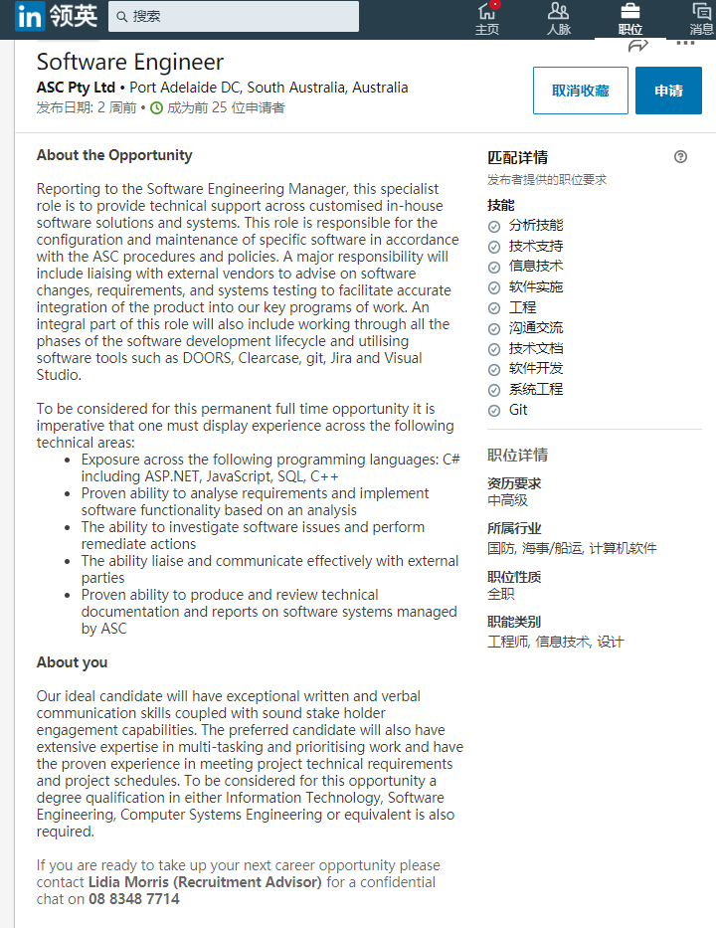

**Signed Checklist**

